**Billing Error Correction**

If Billing Error correction is followed by (Manage AOTS Error/Awaiting Ticket Resolution) please follow the below steps to resolve this error.

Billing Error correction is auto generated system task which is created when GCP DB is incomplete.

**Use the below query to fetch the task ID**:

/*Suborder Level check for MIS and BVOIP*/

**Inconcert SqL Query:** -

Select ord.purge_IND,ms.ms_task_id,ord.usrp_order_number,sub.order_gate1_status, sub.ms_sub_order_id,sub.wan_link_ip_addr, wf.name, wf.status, wf.job_id, wf.task_id, wf.first_ready_time,wf.ready_time, wf.due_date, wf.done_time, wf.first_ready_time,wf.skipped_time, wf.perform_condition, wf.ITERATE_CONDITION

from ms_order ord, ms_sub_order sub,ms_job j,wf_task wf,wf_job job,ms_task ms

where

Ord.Usrp_Order_Number In

('157512824')and ord.ms_order_id = sub.ms_order_id and ms_sub_order_id = j.entity_id

and wf.job_id= hextoraw(j.wf_job_id) And Wf.Job_Id = Job.Job_Id and wf.task_id= ms.WF_TASK_ID

and j.entity_type=5 and (wf.status in (1));

**mS Updates SQL Query:-**

SELECT usrp_order_number, o.ms_order_id, ms_sub_order_id, t.name, t.status_updated_date , t.status, t.* FROM ms_task t, ms_job j, ms_order o , ms_sub_order so WHERE usrp_order_number IN ( '194943727' ) AND so.ms_order_id = o.ms_order_id AND entity_id = ms_sub_order_id AND entity_type = 5 AND t.wf_job_id = j.wf_job_id and t.status = 1;

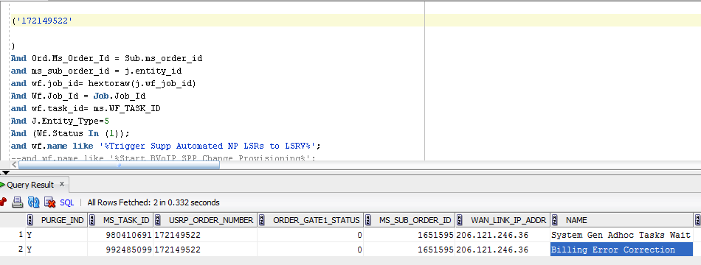

Get the task ID 02000017068E8CFA44E400020001C312 from the same query and force complete the task

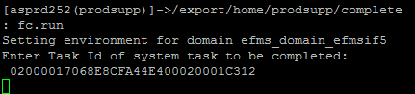

You will get the below screen

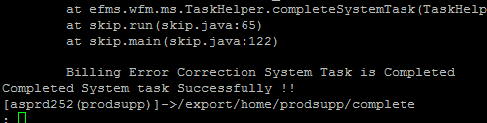

This step will retry the task,if workflow progresses towards completion then close the USH ticket.

**If task comes back then follow the below mentioned steps**:

**EFMS GUI** [**URL :-**](URL:-)

[**http://efmsms.it.att.com:8008/MS**](http://efmsms.it.att.com:8008/MS)

**Step 1:** Open the order in EFMS GUI , click on order suborder,Hit OPEN

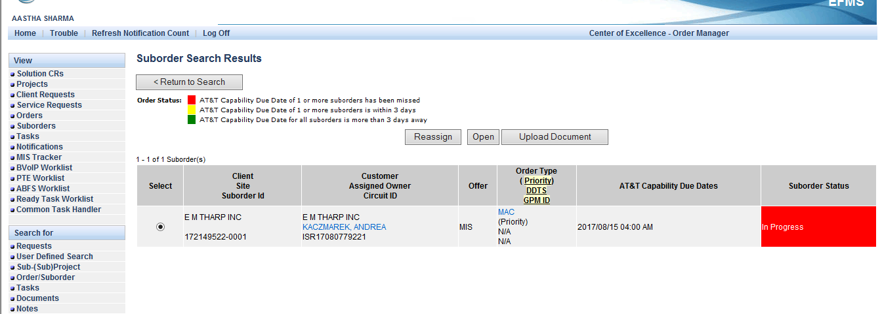

**Click on activity logs**

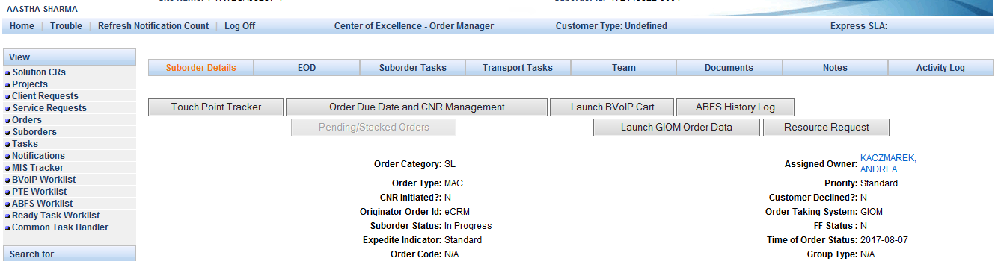

Fetch the error details from GUI, for example in this case**:**

|  |  |  |
| --- | --- | --- |
| 2017-08-28 05:33 PM | Workflow | Provision BVoIP Billing via BGW Transaction with BGW succeeded |
| 2017-08-28 05:33 PM | Workflow | Receive BGW Billing Reply has an error.'Billing Error Correction' is created. |

If error is due to GIOM then engage GIOM, for example**:**

2017-07-28 11:21 AM Workflow Billing DB Update via GIOM Transaction with GIOM succeeded.  
2017-07-28 11:21 AM Workflow Receive GIOM Billing DB Update Reply has an error.'Billing Error Correction' is created.

**Step 2**: To fetch error logs, use wfm command to retrigger task “Provision BVoIP Billing via BGW”

Command to be used: /opt/project/bin/wfm_tool -command task.retrigger -taskid 02000017068E8CFAEC1C00020001C427

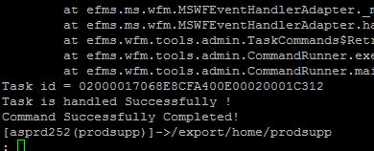

**Note**: Status of Provision BVoIP Billing via BGW must be 3(Complete).

Once retrigger is complete then login to ssh asprd252.aldc.att.com, under prodsupp

Use the below steps:

1. cd /opt/project/log/bvoip



1. grep ordernumber *log*

grep 172149522 *log*

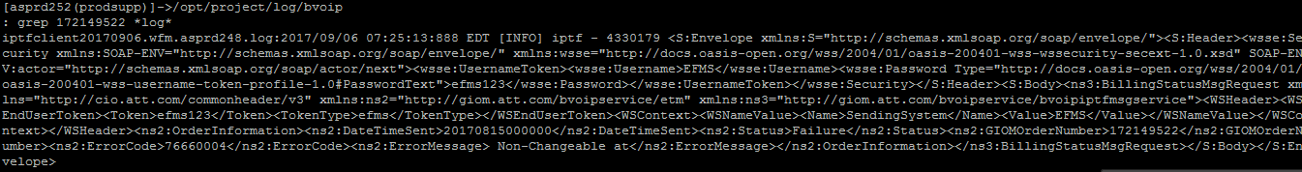

1. cat filename|less

cat iptfclient20170906.wfm.asprd248.log|less

Search the order number using the following command “/ordernumber”

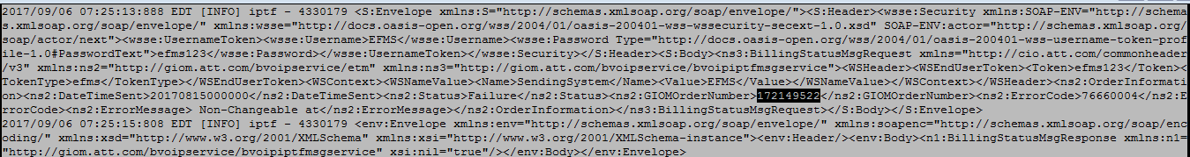

**Note** : Transaction name is BillingStatusMsgRequest

For old days logs use this path “/opt/app/pre_sales_files/oldlogs/LOG/MS_LOG/2017/08/24” [Change the date when the task was retriggered] instead of grep use “gzgrep” and to view file use “gzcat”

**Step 3**: Further engage GIOM/GCP/BGW/CADM after checking the error sending system once billing is corrected segment skip task “Provision BVoIP Billing Part2” if we do not require RETRY.

**Step 4**: Recheck the workflow if order has now progressed then only close the ticket